  - Documentation
To start the program:
The program expects 4 arguments when started, in the format:
- <csv|json> <parking file> <properties file> <population file>
An example of the 4 arguments (in the IntelliJ interface):
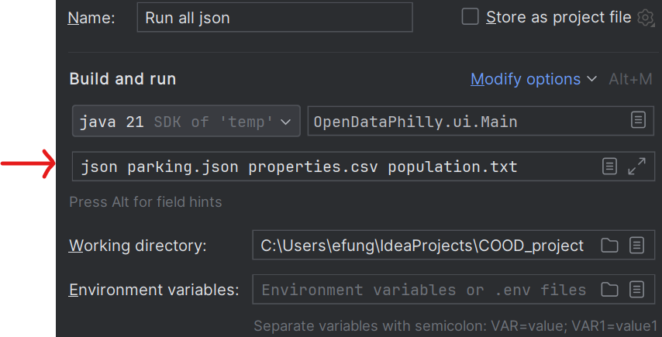
After starting, the program shows the Main Menu, which has numbered options:
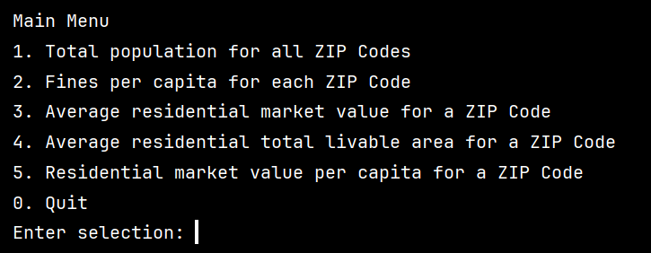
After “Enter selection:”, the user will type in a single number between 0 and 5, followed by “Enter.” Then, the corresponding option will be initiated:
Option 1: Total population for all ZIP Codes
- Input: 1
- Output: <total population>
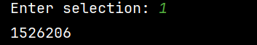

Option 2: Fines per capita for each ZIP Code
- Input: 2
- Output: <ZIP code> <fines per capita>
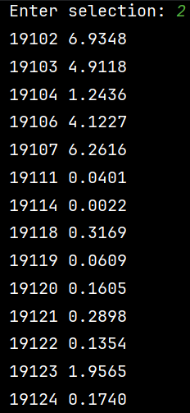
Option 3: Average residential market value for a ZIP Code
- Input: 3
- Prompt: Enter ZIP Code:
- Input: <ZIP Code>
- Output <average residential market value >
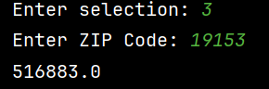
Option 4: Average residential total liveable area for a ZIP Code
- Input: 4
- Prompt: Enter ZIP Code:
- Input: <ZIP Code>
- Output <average residential total liveable area >
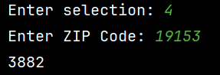
Option 5: Residential market value per capita for a ZIP Code
- Input: 5
- Prompt: Enter ZIP Code:
- Input: <ZIP Code>
- Output <residential market value per capita >
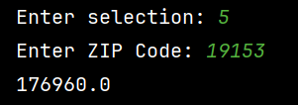
After executing the particular option, the main menu screen will appear again. The user can enter their selection again, repeating the above process.
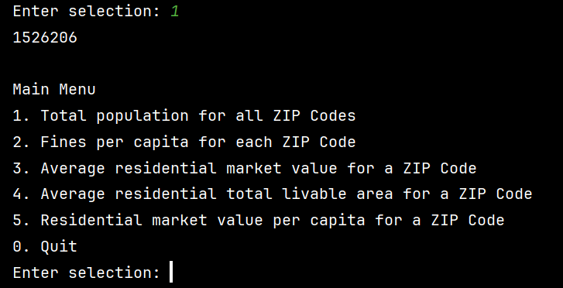
If the user enters any number that is not between 0 and 5, or a non-integer input, they will be ignored and the main menu will be shown again until the user enters a valid selection.
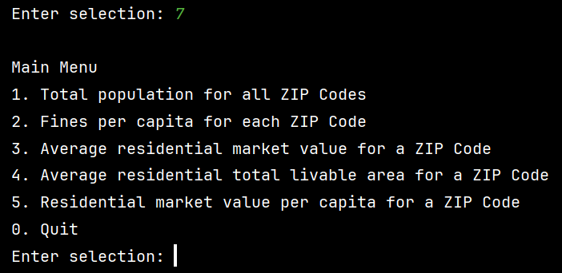
To exit the program, the user enters 0. A farewell message will appear and the program will end. An exit code 0 will denote that the program finished successfully without errors.
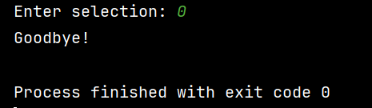

  - UML Diagram:
